A Program for Follow-Up and Quality Assurance of Electret Results
B. Sarusi¹ , S. Levinson^{1*}, N. Lavi², U. German¹
¹ Nuclear Research Center, Negev, P.O.B 9001 Beer Sheva, 84190, Israel.
² Environmental Lab, Ben-Gurion University of the Negev, Beer Sheva, 84105, Israel.

*Corresponding Author: sea-and-spa@013.net
INTRODUCTION
The most important naturally occurring radio-nuclides in the environment are ⁴⁰K and ²³⁸U and ²³²Th, which are heads of decay series. Building materials may also contain enhanced levels of naturally occurring radioisotopes which may be sources of external and internal radiation exposure in dwellings. The external exposure is due to the direct radiation from the radioisotopes in the decay series of ²³⁸U and ²³²Th, and among these daughters, two Radon isotopes are produced: ²²²Rn is a daughter in the chain of decay of ²³⁸U and ²²⁰Rn is a daughter in the ²³²Th chain. Radon is a gas, it undergoes diffusion in the building material and exhalation to the surrounding. Besides, radon is emanated also from soil and its concentration can be significant in radon prone areas. Inhalation of air with increased level of Radon causes internal exposure, which is the greatest contribution to the exposure of individuals to natural radiation. Therefore, accurate measurement of radon concentration is of great importance.
There are several methods to determine the radon concentration in air. The Israeli regulation for measuring the radioactive content in building materials⁽¹⁾ specifies three methods for radon concentration measurements: applying continuous monitoring, using Electrets and using active charcoal cassettes. Using Electrets is convenient, as a relatively simple stand-alone system can be used. The follow-up and quality assurance of Electrets results is the subject of the present work. For this purpose a computer program was developed which handles the Electrets results database and applies various tools for analysis.

MATERIALS AND METHODS
An Electrets is a charged Teflon® disk, mounted inside a small chamber^{(2,3)}. Radon gas diffuses into the chamber through filtered inlets, and the alpha particles emitted by the decay ionize air molecules. Negative ions produced inside the chamber are collected on the positively charged Electret, causing a reduction of its surface charge. Thus, the Electrets serves both as a source of electrostatic field and as a sensor. The change in voltage, which is a function of the radon concentration, is measured by a sensible voltage reader. In the present work EIC's (Electret ion chambers) made by Rad Elec Inc. (5714-C Industry Lane, Frederick, MD 21704, USA) were used. The basic components of the E-PERM® Electrets system are shown in Fig.1. The Electrets are accurate devices, but they are susceptible to some environmental effects, which may induce significant errors. The main effect are mechanical shocks, dirt/dust, humidity^{(4,5,6)}. Also improper operation of the shutter handle when measuring the voltage may produce results deviating from the proper values. Therefore, at least 2 equal sequential measurements are needed for a valid result.
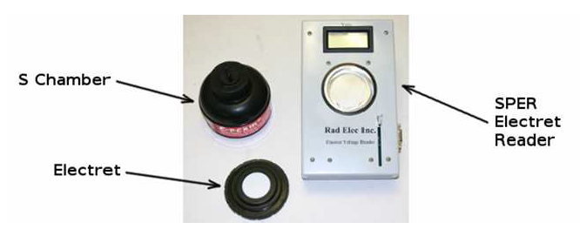
Figure 1. The E-PERM® Electrets system

THE COMPUTER PROGRAM
The general flow chart of the computer program is presented in Fig. 2. The main database contains information on each Electret, characterized by its unique serial number. All Electrets readings are displayed, as well as the time of reading, the readout equipment used and the reading status (voltage follow-up, voltage check before exposure, readout after exposure, etc.). All historical data is contained in the database, from beginning of use of each Electret. to ensure reliable check points and quality assurance of the reader, reference Electrets are also defined in the system. These are highly stabilized Electrets and in addition a blank Electret. Full information on the reference Electrets and their history is included in the database as well.
The database is used to check compliance with all the requirements of the manufacturer and the regulator (ministry of environmental protection) and to issue proper alerts for action. New Electrets come loaded to 700 – 780 volts which allows for 500 usable volts. A valid Electret reading must be higher than 200V, otherwise it must be sent back to the manufacturer for charging. In order to ensure a correctly functioning reader, weekly readings of reference Electrects should be within ±3V of the manufacturer certified readings and the blank ("zeroing") Electret reading should be in the range ±2V. The warning limits can be changed by the administrator of the system, but not by the operator.
The program establishes communication between the reader and the database. The Electret number is written in barcode format and is transmitted directly to the database. Also the voltage values are received from the reader and are input automatically into the database.
A valid reading is defined as the value of two consecutive equal voltages out of up to 10 readings. In order to facilitate the follow-up, to enable an efficient handling of problems, and to observe trends, a graphical presentation of the voltage readings as a function of the reading time is available.

Figure 2. Flow chart of the computer program.
EXAMPLE OF RESULTS
Two typical graphic presentations are given. The first one (Fig. 3) presents data of a valid radon exposure measurement. Before exposing the Electrets, the voltage values are stable. Also after exposure the voltage remains stable and the radon concentration can be calculated from the voltage difference before and after the exposure. A different case can be seen in Fig, 4.

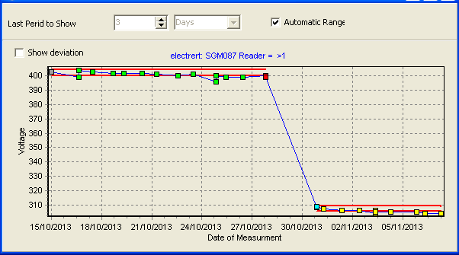

Figure 3. Data of a valid radon exposure measurement.

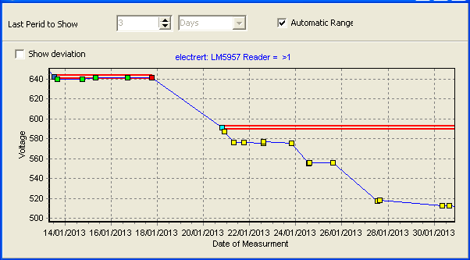

Figure 4. Data of an invalid exposure measurement.
Before the exposure the voltage was stable, but after the exposure there is a non-normal behavior. The first two readings were close, but afterwards a slip of about 15V occurred. The next 4 readings were stable, but then another drift occurred. This behavior does not allow us to determine with acceptable accuracy the radon concentration. It is possible that this drift was caused by some dirt accumulated on the Electret during its use.

CONCLUSIONS
A computerized tool was developed which greatly improves the handling and follow-up of data used to evaluate the radon concentrations by Electrets. The voltage readings are directly placed into the database, statistical analysis is performed and the validity of the readings are checked. All readings of the reference Electrets are included in the database as well. The graphic presentation of data enables a clear observation of behavior and trends. Using the program greatly improves the quality assurance of radon concentration determination when using Electrets. The program is under development. Its expansion will include calculations of radon concentrations based on the voltage readings.

REFERENCES
- SI 5098, 2009. Content of radioactive elements in building products. The standards institution of Israel.
- Kotrappa, P., Brubaker, T., Dempsey, J.C., Stieff, L.R., 1992. Electret ion chamber system for measurement of environmental radon and environmental gamma radiation. Radiation Protection Dosimetry 45, 107–110.
- US Patent nr. 4,992,658. Ramsey Jr. et al. 1991.
- Denman, A.R., Groves-Kirkby, C.J., Phillips, P.S., Krockett, R.G.M., Woolbridge, A., Gillmore, G.K., 2005. The practical use of Electrets in a public health radon remediation campaign. J. of Envir. Radioactivity, 84, 375-391.
- Mahat, R.H., Bradley, D.A., Amin, Y.M., Wong, C.Y., Su, L.D., 2001. The effect of humidity on the accuracy of measurement of an Electret radon dosimeter. Radiat. Phys. Chem. 61, 489–490.
- Sorimachi, A., Takahashi, H., Tokonami, S., 2009, Influence of the presence of humidity, ambient aerosols and thoron on the detection responses of Electret radon monitors. Rad. Measuremeants 44, 111-115.

